EDF schedular

1 Verifying tasks• T1: Button_1_Monitor (P=50, C=0.012, D=50).  
• T2: Button_2_Monitor (P=50, C=0.012, D=50).  
• T3: Periodic_Transmitter (P=100, C=0.013, D=100).  
• T4: Uart_Receiver (P=20, C=0.012, D=20).  
• T5: Load_1_Simulation (P=10, C=5, D=10 ).  
• T6: Load_2_Simulation (P=100, C=12, D=100).  
  
2 Hyper PeriodThe hyper period is the least common multiplier of all tasks’ periodicities, 𝐻 = 100 𝑚𝑠.  
3 Calculating CPU loadCPU load or Utilization (𝑈) is the percentage of time of executing tasks in the hyper  
period to the hyper period.  
3.1 Analytical method𝑈 =∑𝑛 𝑖=1 (𝑃𝐻𝑖) × 𝐶𝑖/𝐻  
=((100 50 ) × 0.012 + (100 50 ) × 0.012 + (100 100) × 0.013 + (100 20 ) × 0.012 + (100 10 ) × 5 + (100 100) × 12 )/ 100 = 0.621 = 62.1%

**3.2 Offline simulation method using SimSo**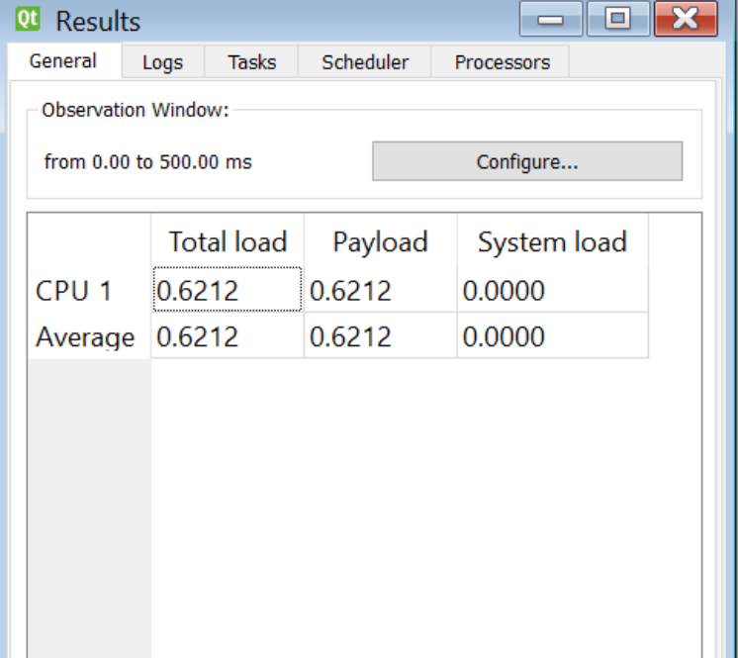

**4 Schedulability check**Assuming the given set of tasks is scheduled using a fixed priority rate-monotonic  
scheduler then the verifying tasks’ priorities will be:  
𝑝1 = 2  
𝑝2 = 2  
𝑝3 = 1  
𝑝4 = 3  
𝑝5 = 4  
𝑝6 = 1  
  
**4.1 Utilization rate-monotonic URM method**𝑈𝑅𝑀 = 𝑛 (2(𝑛1) - 1) = 6 (2(1 6) - 1) =0 .7347 = 73.47%  
𝑈 = ∑ 𝐶i/ 𝑃𝑖 = 0.012/50 + 0.012/50 + 0.013/50 + 0.012/20 + 5/10 +12/100 = 0.621 = 62.1%  
  
As 𝑈 < 𝑈𝑅𝑀 and 𝑈 < 100% then these tasks are guaranteed schedulable.  
  
**4.2 Time demand method**Tasks are checked in order depending on their priorities. The time required for

|  |  |
| --- | --- |
| each task is calculated from 𝑊𝑖(𝑡) = 𝐶𝑖 + ∑ | (𝑃i/𝑡) ×𝐶𝑖 |

as 𝑡 is the deadline of this task.

**4.2.1 T5 checking**T5: (P=10, C=5, D=10).  
Time required = 10.  
Time provided: 𝑊5(10) = 5 + 0 = 5 < 10 (schedulable).

**4.2.2 T4 checking**T4: (P=20, C=0.012, D=20).  
Time required =20.  
Time provided: 𝑊4(20) = 0.012 + (20/ 10) × 5 = 10.012 < 20 (schedulable).

**4.2.3 T1 and T2 checking**T1: (P=50, C=0.012, D=50).  
T2: (P=50, C=0.012, D=50).  
  
As both tasks have the same deadline then we can’t predict which one will execute  
first but as both of them has the same execution time so if the last executed one of them  
is schedulable whatever each one is the first and each is the last then both of them are  
schedulable.  
𝑊1,2(50) = 0.012 + (50 10) ∗ 5 + (50 20) ∗ 0.012 + (50 50) ∗ 0.012 = 25.06 < 50 (schedulable).

**4.2.4 T3 and T6 checking**T3: (P=100, C=0.013, D=100).  
T6: (P=100, C=12, D=100).

As both tasks have the same deadline then we can’t predict which one will execute first  
and the two tasks have different execution times so every task will be treated to be the  
last executed one as a worst-case scenario.  
𝑊3(100) = 0.013 + (100 /10 ) ∗ 5 + (100 /20 ) ∗ 0.012 + (100/ 50 ) ∗ 0.012 + (100 /50 ) ∗ 0.012 +   
(100 /100) ∗0.013= 62.108 < 100 (schedulable).  
𝑊6(100) = 12 + (100/ 10 ) ∗ 5 + (100 /20 ) ∗ 0.012 + (100 /50 ) ∗ 0.012 + (100 /50 ) ∗ 0.012 +  
 (100/ 100) ∗0.013 = 62.108 < 100 (schedulable).  
 **4.3 Conclusion**The analytical results are the same as SimSo results as all tasks meet their deadlines  
